|  |  |  |
| --- | --- | --- |
| **GCCA+ | Logo** |  |  |

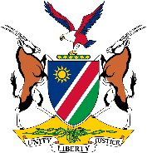

**APPLICATION FORM**

**Research Methodology Internship (RMI) 2024**

***Assessment of marine littoral plastic pollution on beaches along the Benguela Current in the Erongo Region of Namibia***

**Application Deadline: Friday 20 July 2024**

**Personal details**

|  |  |
| --- | --- |
| Surname |  |
| Name(s) |  |
| ID number |  |
| Gender |  |
| Email address |  |
| Cell phone number |  |
| Town of residence (Where do you live?) |  |

**Academic qualifications**

|  |  |
| --- | --- |
| Tertiary institution |  |
| Degree and Year obtained |  |
| Final year subjects |  |

**Why do you want to be part of this programme?** (No more than 100 words)

**What is the effect of plastics in the marine environment?** (No more than 50 words)

***NB: Please attach copies of your ID, CV and highest academic qualification***