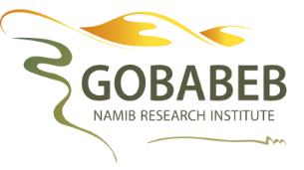
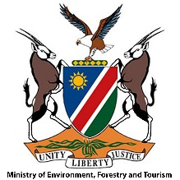
APPLICATION FORM
Climate Action for Millennials Programme (CAMP)
2021 Topic: “The Science of Climate Change and Local Resilience”
Application Deadline: Wednesday 2nd December 2020
NB: Please attach copies of your CV and final-year university transcript

This training course aims to develop science-based knowledge on climate change, and its predicted local effects. You will also create outreach materials to educate at least four groups of secondary school learners in your home town during the first school term of 2021, under the guidance of Gobabeb.

Personal details
Surname
Name(s)
ID number
Email address
Cell phone number

Languages spoken

Town of residence (Where do you live?)

Academic qualifications
Tertiary institution
Degree and Year obtained

Which university subject did you enjoy most and why? (No more than 50 words)

Which school subject did you enjoy most and why? (No more than 50 words)

Do you have any teaching / mentoring experience?

Have you been a member of an environmental group? Which?

Why do you want to learn more about climate change? (No more than 100 words)

Do you think secondary school learners should be taught about climate change and its expected local impacts? Why? (No more than 100 words)

Tell us something about yourself that is not mentioned here or on your CV. (No more than 20 words)

